Ian Thompson (HMS Ganges Assoc. Qld)

**KILROY WAS HERE**

**All of you who are approaching my age, (or just enjoy trivia) willremember this, so “Here’s the Rest of the Story (unless you alreadyknow it.) I found it interesting.**

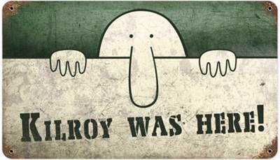

**http://www.shangralafamilyfun.com/galk-o/kilroyline.gif**

**He is engraved in stone in the National War Memorial in Washington, DC- back in a small alcove where very few people have seen it.  For the WWII generation, this will bring back memories.  For you younger folks, it's a bit of trivia that is a part of our American history.  Anyone born in 1913 to about 1950, is familiar with Kilroy.  No one knew why he was so well**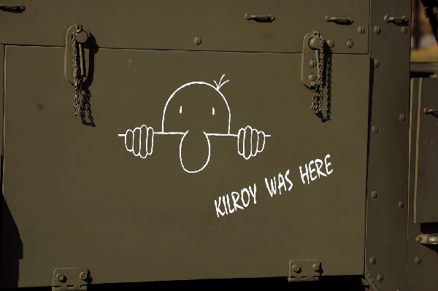

**In 1946 the American Transit Association, through its radio program, "Speak to America ," sponsored a nationwide contest to find the real Kilroy, offering a** [**prize**](http://www.shangralafamilyfun.com/kilroywashere.html) **of a real trolley car to the person who could prove himself to be the genuine article.  Almost 40 men stepped forward to make that claim, but only James Kilroy from Halifax, Massachusetts, had evidence of his identity.**

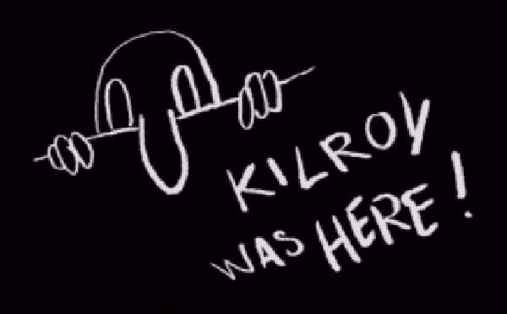

**'Kilroy' was a 46-year old shipyard worker during the war who worked as a checker at the Fore River Shipyard in Quincy. His** [**job**](http://www.shangralafamilyfun.com/kilroywashere.html) **was to go around and check on the number of rivets completed.  Riveters were on piece work and got paid by the rivet.  He would count a block of rivets and put a check mark in semi-waxed lumber chalk, so the rivets wouldn't be counted twice.  When Kilroy went off duty, the riveters would erase the mark.  Later on, an off-shift inspector would come through and count the rivets a second time, resulting in double pay for the riveters.**

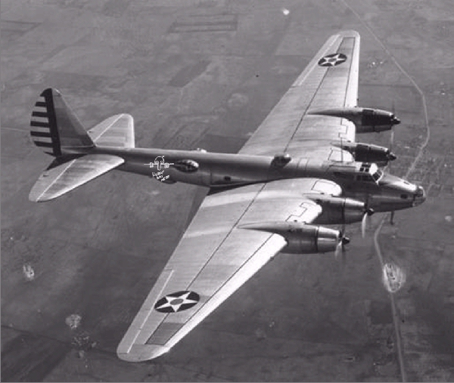

**One day Kilroy's boss called him into his office.  The foreman was upset about all the wages being paid to riveters and asked him to investigate.  It was then he realized what had been going on.  The tight spaces he had to crawl in to check the rivets didn't lend themselves to lugging around a paint can and brush, so Kilroy decided to stick with the waxy chalk.  He continued to put his check mark on each job he inspected, but added 'KILROY WAS HERE' in king-sized letters** [**next**](http://www.shangralafamilyfun.com/kilroywashere.html) **to the check  and eventually added the sketch of the chap with the long nose peering over the fence and that became part of the Kilroy message.**

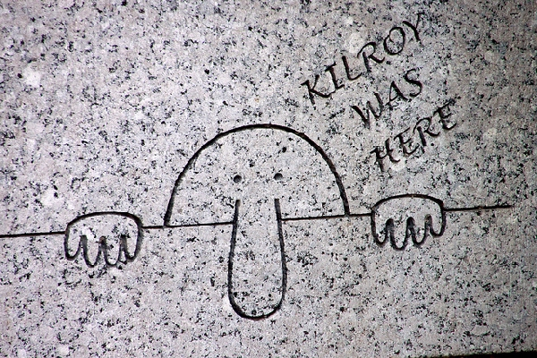

**Once he did that, the riveters stopped trying to wipe away his marks. Ordinarily the rivets and chalk marks would have been covered up with paint. With the war on, however, ships were leaving the Quincy Yard so fast that there wasn't time to paint them. As a result, Kilroy's inspection "trademark" was seen by thousands of servicemen who boarded the troopships the yard produced.**

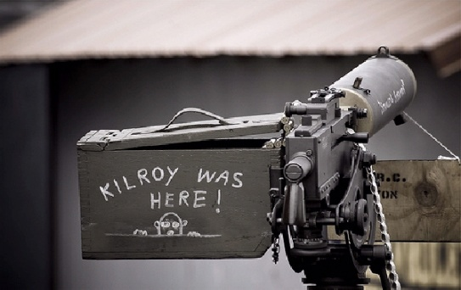

**His message apparently rang a bell with the servicemen, because they picked it up and spread it all over Europe and the South Pacific.**

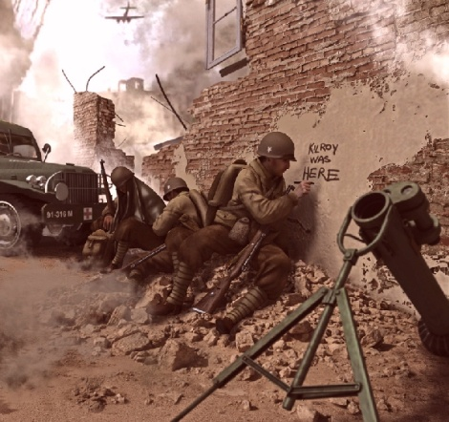

**Before war's end, "Kilroy" had been here, there, and everywhere on the long hauls to Berlin and Tokyo.  To the troops outbound in those ships, however, he was a complete mystery; all they knew for sure was that someone named Kilroy had "been there first."  As a joke, U.S. servicemen began placing the graffiti wherever they landed, claiming it was already there when they arrived.**

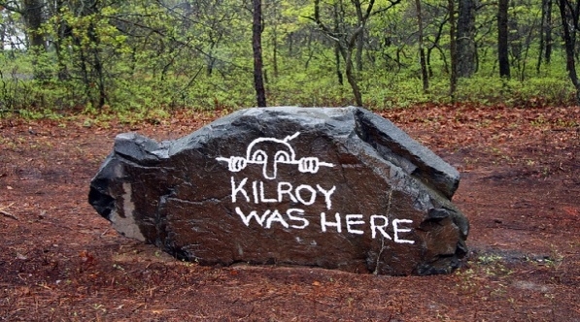

**Kilroy became the U.S. super-GI who had always "already been" wherever GIs went.  It became a challenge to place the logo in the most unlikely places imaginable (it is said to be atop Mt. Everest, the Statue of Liberty, the underside of the Arc de Triomphe, and even scrawled in the dust on the moon.**

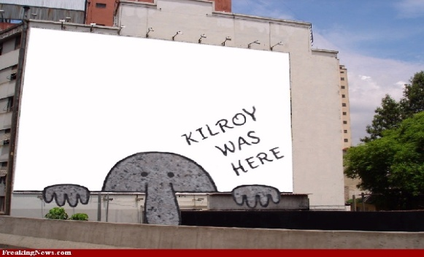

**As the war went on, the legend grew.  Underwater demolition teams routinely sneaked ashore on Japanese-held islands in the Pacific to map the terrain for coming invasions by U.S. troops (and thus, presumably, were the first GI's there).  On one occasion, however, they reported seeing enemy troops painting over the Kilroy logo!**

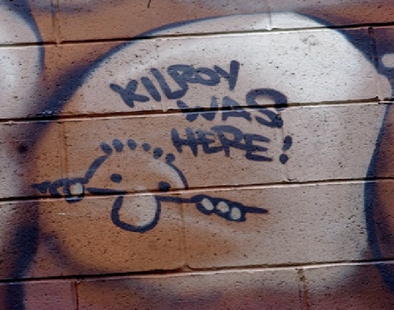

**In 1945, an outhouse was built for the exclusive use of Roosevelt, Stalin, and Churchill at the Potsdam conference.  Its' first occupant was Stalin, who emerged and asked his aide (in Russian), "Who is Kilroy?"**

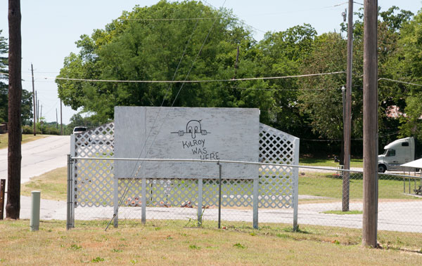

**To help prove his authenticity in 1946, James Kilroy brought along officials from the shipyard and some of the riveters.  He won the trolley car, which he gave to his nine children as a Christmas gift and set it up as a playhouse in the Kilroy yard in Halifax, Massachusetts.**

**And The Tradition Continues...** 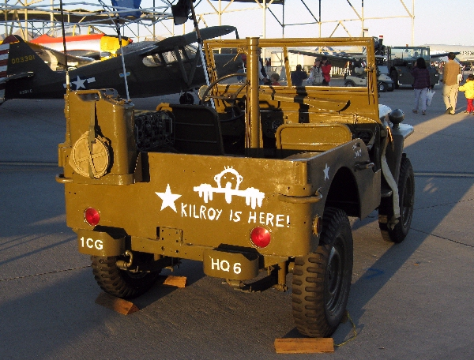

**EVEN Outside Osama Bin Laden's House!! !** 